127R-23

CHOOSING AMONG STRATEGIC ALTERNATIVES USING RISK ANALYSIS CONCEPTS IN DECISION MODELLING
TCM Framework: 3.3: Investment Decision Making
7.6 Risk Management

May 26, 2023

1 TABLE OF CONTENTS
2
- Table of Contents 1
- 1. Introduction 2
- 2. Recommended Practice 2
- 2.1. Using Analysis to Examine Strategy Decisions from the Risk Point of View 2
- 3. Two Alternative Approaches to Analyze Consequences of a Lack of Technology Readiness 4
- 3.1. Probabilistic Branching – Representing the Decision about Adopting a New Technology in the Schedule 4
- 3.1.1. Structure of a Probabilistic Branch 5
- 3.1.2. Probabilistic Branch Risk Data 6
- 3.1.3. Simulation Results, Consequences for the Project 7
- 3.1.4. Mechanics of the Simulation: How the Probabilistic Branch Works 8
- 3.2. Conditional Branching – Representing the Risk: Timely Readiness of New Technology 10
14 3.2.1. Context 10
- 3.2.2. Setting the Conditions for the Decision 10
- 3.2.3. Considerations for a Conditional Branching Model 11
- 3.2.4. The Conditional Branching Model 12
- 3.2.5. Modelling the Schedule Uncertainty of the Initial Exploration of New Technology 12
- 3.2.6. Settling on the Trigger Date 12
- 3.2.7. Settling on a Medium Range of Risk for the Initial Exploration of New Technology 13
- 3.2.8. How the Conditional Branching Model Works 14
- 4. Conclusion 15
- References 16
- Contributors 16
25
26

27 1. INTRODUCTION
28
- During the initiation phase for any significant project, strategic alternatives are being developed and one of the main
- considerations will include the balance of risk in any alternative. This recommended practice (RP) addresses
- analyzing risk in an alternative selection process simplified to highlight the important risks that make a difference
- about which project to do, (or which alternative to select) its configurations and whether to do a project at all. This
- recommended practice is associated with the TCM chapters 3.3 Investments Decision Making and 7.6, Risk
- Management. [1]
35
- The purpose of this RP is to describe and discuss some of the risk analysis concepts that can be used when these
- important alternative selection strategies are being developed by senior management of any project-oriented
- organization. These important selections are made well before there is a project plan, schedule and cost estimate.
- The RP proposes to develop models simplified to highlight the key risk characteristics of an alternative under
- consideration and some concepts that are available currently to address them. These concepts bring an additional
- level of clarity, transparency, traceability, repeatability and consistency with recommended practices of project risk
- analysis. Simple models were developed to illustrate two of these methods, probabilistic branching and conditional
- branching. One of the desired outcomes is to introduce these methods and their use to organizational senior
- management and engage them in the use of risk analysis for strategic alternative selection. 45
- This RP document is not intended to be a standard. Rather it is intended to provide a guideline for using project risk
- analysis simulation capabilities of probabilistic and conditional branching to evaluate alternative selection within a
- simplified model of the project’s strategy. RPs are considered by most practitioners to be good practices that can be
- relied on and that they would recommend be considered for use where applicable. The RP is most likely to be useful
- to organizational leaders and decision makers, project management and risk team leaders. 51
52

53 2. RECOMMENDED PRACTICE
54
- It is recommended that organizations faced with strategic decisions follow structured decision analysis (DA)
- frameworks and practices. The process steps of (1) Structuring, (2) Evaluation, (3) Agreement, and (4)
- Implementation are discussed in Section 3.3.1.1 of TCM. This RP especially fits into steps (1) and (2) and contributes
- to steps (3) and (4).
59
- As an application example, an organization faces a strategic capital expansion decision: A large, complex plant for
- producing an important product must be built to fortify their market share. Two camps of executives are debating
- the new plant’s configuration. Some see this as an opportune time to lead the industry by inserting a new
- technology. Other leaders believe that the new technology may be difficult to master, and that there is a strong risk
- that they cannot make it ready for this project in time to capture market share as required. They insist on at least
- having an alternative Plan B available to switch to the existing technology if the new technology becomes difficult
- and takes a long time to master. 67
68 Executives representing both points of view share a sense of urgency. They understand that their prime competitor
69 is also building a production plant. If this team’s project fails by being late to launch, the competitor can gain
70 significant advantage as being first to market with the product. They also agree that the risk associated with
71 deploying the new technology should be a significant factor in their making this strategic decision. 72
73 This RP recommends using risk analysis concepts in decision-making between the two described alternatives. 74
75

76 2.1. Using Analysis to Examine Strategy Decisions from the Risk Point of View

77

- 82
- This RP examines using risk analysis concepts and techniques on the risk component of a strategic decision early in
- the process of structuring and managing the project. These strategic decisions may be more impactful for the project
- than risks that can occur during the execution phase after the project plan has been adopted. And yet the risk
- analyses usually focus downstream on the risk of executing the final plan. [Join this paragraph with the one below] 87
- It advances the risk analysis earlier in the decision-making process and higher up the management ladder than
- usual. At this point, there is no defined project, so there is neither a plan nor an estimate to be examined for contingency
- calculations and risk mitigation. Decisions about fundamental project aspects are yet to be made. It is proposed to
- model the decision that has a strong component of risk to success as soon as the risk impact of alternative choices
- can be discussed.
- . Teams develop a time-phased network
- risk modeling because of the amount of time it takes to analyze the risks to a satisfactory conclusion that includes logically driving interfaces, uncertainties, and risks. The typical schedule structure is
- summarized in detail to focus on the risk aspect of the decision. 96
97 People involved in the strategic decision making for this analysis are different from the typical project management
98 team that carries out the execution. They are in the organization’s leadership positions with decision-making
99 responsibilities. They decide on a project strategy that will guide key decisions to be made later and may be turned
100 into a detailed plan with a cost estimate. 101
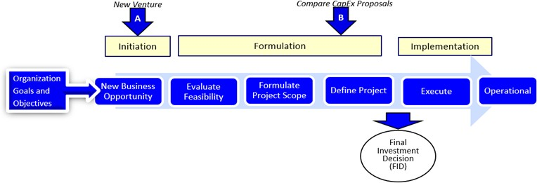
102 The distinction between when the investment risk analysis occurs (point A), which is the focus of this RP, and when the project risk analyses usually occur (point B) is shown in Figure 1. 103

104
105

106 Figure 1: Progress of a Project Decision with Risk Analyses at Initiation and Formulation
107
- At the Initiation and during the Formulation stages important strategy and scoping decisions will be made. Many aspects of
- the alternatives are considered in making those decisions. Risk is one of those aspects described in this RP. The
- benefits of reviewing the technical readiness risk upstream of the project final investment decision include: 111
- • Highlighting risk aspects of decisions. Risk to a project is important but may not be the controlling factor for the
- company’s leadership decision making process. While there is a risk component in decision making, there is a concern that risk is talked about
- without applying methods of analysis that are available to project risk analysis professionals. This may occur

- because the company may not follow this type of risk analysis in their processes and culture. Either because they lack professionals with the corresponding knowledge and experience in performing this type of analysis, or in some cases, because they apply these techniques only at the final
- investment decision (FID) or even at later points in time.
- • Leadership gains clarity. Risks are examined according to professional recommended practices. These
- methods are known professionally, transparent in application and reproducible, showing results which are
- directly connected to the risks. consistent with AACE first principles.[2]
- • Senior leadership participates in development. The risk model is validated, and assessment understood of
- typical risk parameters; probability of occurring and impacts on activity durations and costs if they were to
- occur, and mapping into the risk model’s structure. This awareness may also lead to mitigation approaches
- that change the pre-mitigated condition and therefore the consequences of residual risk that yet remain.
- Leadership will then own the risk. Their decisions will benefit from a clear analysis of the shape of the risk
- and its consequences. Their attention to risk analysis and management will be strengthened. Execution
- teams can build on risk models initiated by leadership for continuity. 127
- The risk models shown in this RP strip away much of the detail of the typical project to shine the spotlight on the risk
- aspect of leadership’s discussions. While this RP focuses on one technological readiness risk, there may be several
- key risks, and each can be modeled. Then, a consolidated risk model may be made to illustrate their interrelated
- consequences to the project. For research relevant to this RP, see the Government Accountability Office (GAO)
- Technology Readiness Assessment Guide [6].
133
134

135 3. TWO ALTERNATIVE APPROACHES FOR ANALYZING STRATEGIC DECISIONS
136
- Two standard risk methodologies are presented in this RP that can be used in simplified models to highlight the risk
- aspect of a strategic decision. These methodologies are known to risk analysis practitioners but may not have been
- extended to analyzing strategic up-stream decisions. They are probabilistic branching and conditional branching. 140
- Probabilistic branching examines the probability that a technology will not pass a key test.
- • While passing the test is what is represented in the schedule, test failure is a possibility.
- • Failure is represented by a simple probability of occurrence, with consequential activities of understanding
- the causes of failure, planning fixing the technology, implementing the plan and to re-test the technology.
- • With probabilistic branching the date of finishing with a desired level of confidence is the chosen result. 146
- Conditional branching models behavior of the decision maker more flexibly.
- • In Plan A, management decides the date, called the “trigger date,” on which the new technology must be
- adopted or rejected in favor of switching to Plan B:
- • Plan B, an existing, less risky but adequate technology.
- • Both of the alternative plans, A and B, are programmed in the model.
- • The initial examination of the new technology activity will be risky depending on its technological readiness.
- • In simulation of the model, on every iteration the new technology may or may not achieve timely readiness.
- • The model chooses Plan A or Plan B depending on whether the initial assessment of the new technology is
- completed favorably and in a timely fashion.
- • One result is to produce the completion date at some level of confidence, and another is to differentiate
- between technologies used to achieve that result. 158
159

160 3.1. Probabilistic Branching – Representing the Decision about Adopting a New Technology in the Schedule
161

162 In this simplified, risk-oriented model, the main risk is on the duration of the initial exploration of the new technology,
163 as shown in Figure 2:
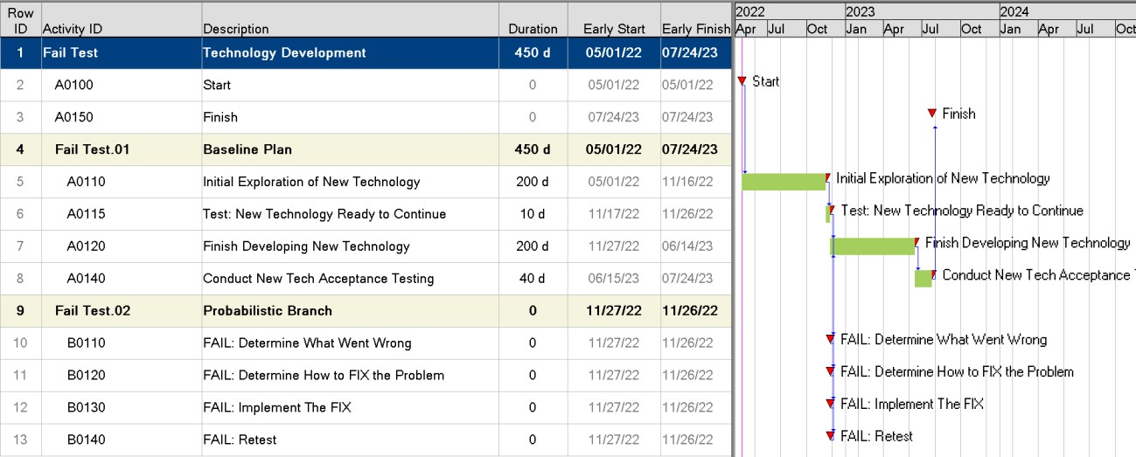
164

165
166

167 Figure 2: Probabilistic Branch Representing Possible Failure of the Initial Test of New Technology
168
- Initial Exploration of the New Technology, Activity A0110, is a 200-day activity. It has been assessed to have a wide
- uncertainty 3-point estimate range of 200d, 300d and 600d. If the new technology passes the readiness test after
- initial exploration, then the baseline plan using the new technology for the project can be implemented straight-
- away in the development and final acceptance testing.²
173
174
175 3.1.1. Structure of a Probabilistic Branch
176
- On the example above, if the new technology does not pass the test, (Activity A0115), there are four activities modeled in series that make up
- the probabilistic branch. All four activities must occur in order to resume the baseline plan. They are: “Determine
- What Went Wrong, Determine How to FIX the Problem, Implement the FIX, and Retest”. These four activities, linked
- with finish-to-start logic, are included in the schedule with durations of zero days, for they have durations only when
- the probabilistic branch is active. 182
- The two successor activities in the Baseline Plan group (A0120 and A0140) would have risks and uncertainties of
- their own that drive a distribution of A0140 finish dates. Since those risks apply to the cases whether the new
- technology fails or passes the test the first time, their probability and impact parameters are not detailed in a
- separate table. They should be specified with care to be realistic. These risks on baseline plan activities are
- represented as risk drivers with impacts on durations expressed as multiplicative factors since the activities to which
- they are applied have durations with remaining durations. When a risk driver occurs on an iteration, its relative

² The main risks were identified and assigned to the initial technology exploration, while the initial testing, continued technology development and acceptance testing also had risks applied. This is a simple model for illustration purposes. Practical limits to the number of branches exist. The practice of embedding branches within other higher-level branches is discouraged.

- impact will be implemented by multiplying the schedule duration by values (factors or percentages) chosen from
- probability distributions of those factors.³ 191
- Similarly, the probabilistic branch shown in Figure 2 succeeds the activity A0115 “Test New Technology Ready to Continue”.
- The probabilistic branch is activated upon test failure and leads to the activity ID B0110, “FAIL: Determine What
- Went Wrong” and, in series, its three successors. All four of the activities in the probabilistic branch occur only if the
- new technology fails the initial test. They are entered with zero durations so they have no impact on the baseline
- plan unless the branch is activated. 197
198
199 3.1.2. Probabilistic Branch Risk Data
200
- Risk data are typically collected in interviews. In those cases where there is concern that the responses may be biased, the interviews are recommended to be done in separate groups, by individuals, or completely confidential. In this way, the interviewees can speak candidly and provide information on
- probability and impact without fear of personal repercussions from management or others. As stated, interviewing in this way
- combats many biases that occur during risk workshops. One particular bias to be considered is when the preferred response is
- always “Zero!” to the question: “How likely is this technology to have a serious failure at the initial test?” This answer
- anchors other probability estimates, because the respondent knows a likely failure could seriously jeopardize the
- project’s approval and final outcome. This tendency, referred to as “anchoring and adjusting,” has been known to
- strongly influence some test teams. [4,5]
- It is recommended that multiple qualified participants be invited to supply their independent opinions
- about likelihood and the consequences of failure. At some point, the team needs to reassemble and discuss each
- risk and its parameters, a validation exercise that will also be an opportunity for learning. Results
- are shown in Table 1.
212
213 The probabilistic branch activities have durations set by the risk analyst and project team leaders working with senior
214 management. In this case, the following ranges of durations were assumed to exist.⁴ The team needs to assemble
215 and discuss each risk and the parameters, such as the likelihood of failing the test and the duration of the four
216 summary activities in the probabilistic branch. These values were approved by leadership so they could experiment
217 with the model and understand the challenges of failure in a virtual environment in advance of the actual project. These values would be validated by leadership and risk management professionals for their reasonableness before running the model. 218
Probabilistic Branch Activity | Low | Most Likely | High
 | (Days)
FAIL: Risk Determine What Went Wrong | 20 | 35 | 60
FAIL: Risk on Determine how to FIX the Problem | 25 | 50 | 90
FAIL: Risk to Implement the FIX | 50 | 70 | 120
FAIL: Risk on Retest | 10 | 20 | 40
219

220 Table 1: Durations Assumed for the Probabilistic Branch Activities
221
222
223

³ See Recommended Practice 57R-09 “Integrated Cost-Schedule Risk Analysis using Risk Drivers and Monte Carlo Simulation of a CPM
Schedule.” (AACE International, Revised 2019)
⁴ The ranges are expressed in deterministic days rather than multiplicative factors. This is required since risk drivers’ impacts cannot be applied
against zero-days durations of the activities in the probable branch activities.

224
225
226 3.1.3. Simulation Results, Consequences for the Project
227
- In this example, The likelihood of failing the initial test determines in how many iterations the probabilistic branch is activated. It
- represents the leaders’ aggregate view of the new technology’s readiness for this purpose. In this case, there was a
- difference of opinion: Some leaders thought that the technology is not ready, and that it will fail the initial test in
- 90% of the iterations. Some leaders were much more optimistic and believed the technology will have a failure rate
- of only 10%.
233
234 Running the risk-focused decision model using these parameters produced the results shown in Table 2. These
235 values indicate the difference in delay at the P-80 (80th percentile of success, 20 percent likely to overrun this date)
236 level of confidence is more than 5 months longer if the failure rate is 90% rather than 10%. 237
Failure Rate Assumptions | Finish Date @ P-80 level of confidence
FAIL at 10% Rate | May 24, 2024
FAIL at 90% Rate | October 21, 2024
238

239 Table 2: Schedule Result at P-80 Level of Confidence for Different Failure Rate Assumptions
240
241 Organization leaderships have risk thresholds against which they make decisions. In this illustration, leaders elected to make
242 decisions based on a P-80 level of confidence. Their organization is willing to tolerate risks that drive outcomes in
243 less than the latest 20% of iterations, for those risks affect the cumulative distribution above the organization’s P-80
244 cut-off. This is shown by the comparison of cumulative distribution curves in Figure 3. 245

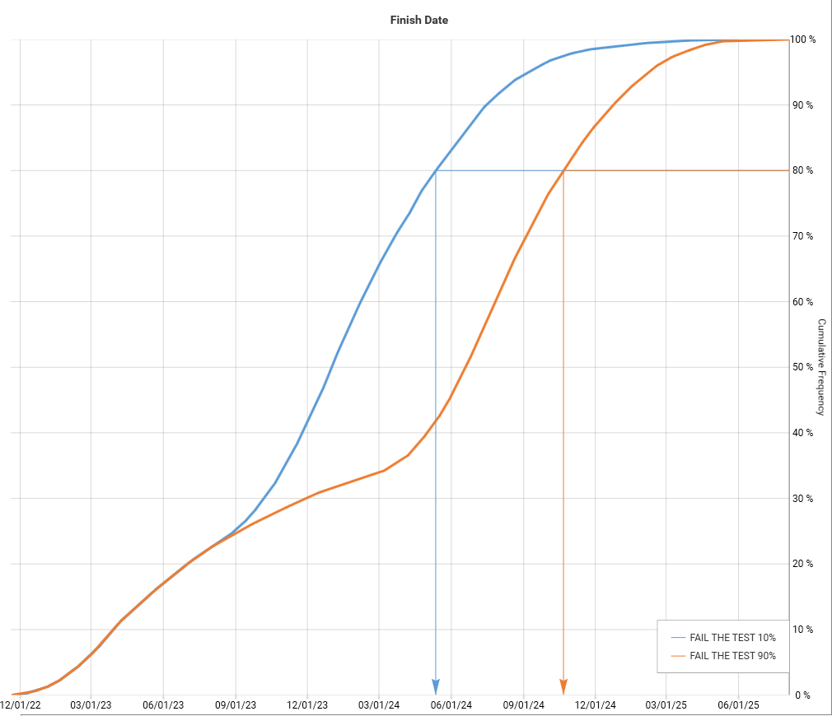
246
247

248 Figure 3: Compare Cumulative Distributions for Different Likelihoods of Failing the Initial Test
249
250
251 3.1.4. Mechanics of the Simulation: How the Probabilistic Branch Works
252
- The two figures below represent the new technology’s failure or success of the initial test. They illustrate how the
- probabilistic branch implements these assumptions during Monte Carlo simulation. In Figure 4, while the iteration
- shown represents uncertainty of durations for baseline plan activities, it reflects success in the initial readiness test.
- The project followed the baseline plan without interruptions from the probabilistic branch in this iteration. This
- result is prominent in the 10% likelihood of failure scenario resulting in P-80 of 24 May 2024 as shown in Table 2. 258

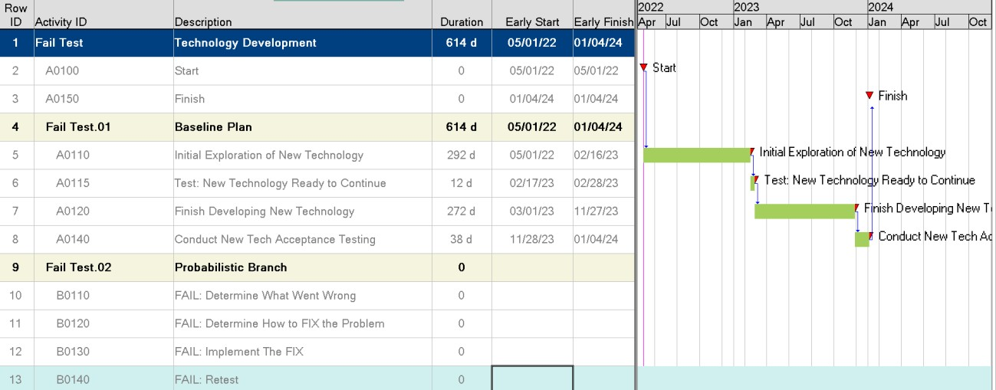
259
260

261 Figure 4: Iteration in Which the Initial Testing of New Technology is Successful
262
- Figure 5 shows an iteration in which the new technology failed the initial readiness test, and the project model
- executed the four activities of the probabilistic branch. Their durations are drawn, for this iteration, from the
- distributions of days added (Table 1 above). The probabilistic branch occurred in 90% of the iterations of the second
- case resulting in P-80 of 21 October 2024 shown in Table 2.
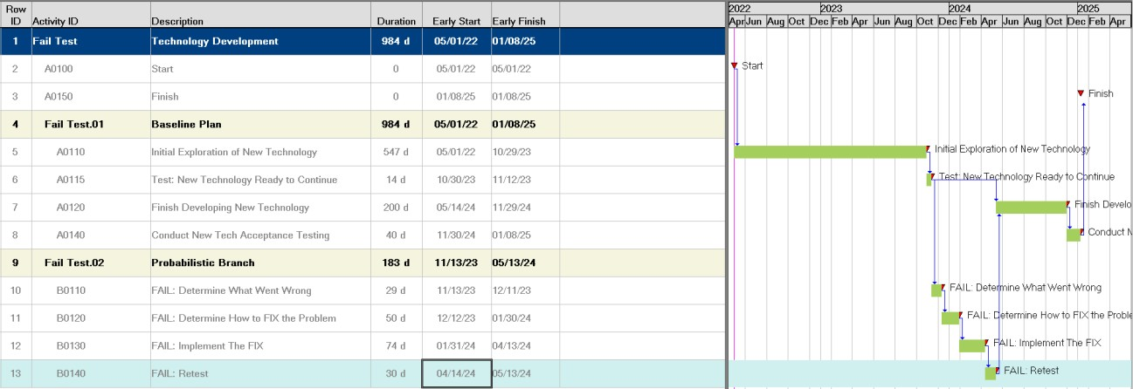
267

268
269

270 Figure 5: Iteration in Which the New Technology Fails the Initial Test, Activating the Probabilistic Branch
271
272 The organization’s leadership need to be aware that completion of the project with the new technology depends on
273 its likelihood of passing the readiness test. Interpretation of results include discussions of the split between
274 successful test results and, perhaps, a range of likely test failures that display as bi-modal distributions. The
275 probability data and consequential activity duration ranges inserted by the probabilistic branch drive the results.
276 Leaders need to make decisions based in part on the results of this simulation. The strategic decision to adopt the
277 new technology should take the possibility of delayed completion into account. The probabilistic branch in the risk
278 model provides a computerized “test bed” for that purpose. A natural extension of evaluating results leads to
279 considering response methods. Notice that the organization’s management team is now discussing risk and
280 evaluating it in deciding on alternatives. 281

282

283 3.2. Conditional Branching – Representing the Risk: Timely Readiness of New Technology
284
285 3.2.1. Context
286
- Conditional branching strengthens Monte Carlo simulation models by representing realistic decision-making
- behavior of project teams when faced with the likelihood that project duration will grow and delay completion. That
- is, conditional branching allows the model to include the risk response tactic known as “contingency planning”.
- Achievement of a scheduled event (such as finishing the readiness test of a new technology) can determine whether
- the project follows the original plan or diverts to an already specified alternative. Representing this decision makes
- conditional branching somewhat more powerful than probabilistic branching as is described below. 293
- The model simulates behavior expected if a project manager finds that the project is not going according to the
- original plan, (Plan A) and test an alternative (contingent) path to assuming a project team must continue with a plan
- the team assesses is likely to result in unacceptable overruns. When faced with this situation, project managers will
- proactively devise and change to a “recovery plan” (Plan B) sometimes called a “recovery schedule,” that provides
- more resources in order to “claw back” the delays under Plan A. Conditional logic enables internal decision making
- to be reflected in the risk model based on unexpected results. 300
- Compared with probabilistic branching, conditional branching adds more powerful and flexible dimensions. As
- shown below, a trigger date may stipulate the date when the decision between Plan A and Plan B must be made,
- perhaps to protect a contractual finish date. This date may be advanced or delayed by management reflecting the
- project’s competitive situation in the market. The conditional branch activities are activated when an internal
- schedule event such as finishing the assessment of a new technology that is included in Plan A overruns its planned
- completion date.⁵ This situation may occur, for example, if a scheduled event is driven by a combination of
- uncertainty and risk embedded in the predecessor activity, “PLAN A: Initial Exploration of New Technology”, and an
- assessment of how long they can wait before they must adopt Plan B. 309
- In this strategic case example, organizational leaders collaborated with the project executives to define a “drop
- dead” or “trigger” date for changing technology development paths if a readiness test was unsuccessful.
- • After that date, if the new technology was not ready for insertion in the project, then Plan B implementing
- a standard technology would be implemented.
- • But, if the new technology passed the readiness test, then the project could proceed with the new
- technology on the original Plan A. 316
317
318 3.2.2. Setting the Conditions for the Decision
319
- Figure 6 represents, in the contingency branching case, the conditions leading to the implementation of Plan B. This
- compares:
- • The risks reflected as occurring on Activity A0110: “PLAN A – Initial Exploration of New Technology”, and
- • Passing the test on Activity A0115: “Test: New Technology Ready to Continue” by the target Date (appearing as
- milestone TR01) that in this example is set at 26 November 2022. 325
- The organization’s managers determine the trigger date, which may be the last day when it is feasible to abandon
- Plan A if it fails the test and to change to Activity CP0100: “Plan B – Modify Existing Technology”.

⁵ This RP illustrates a logical choice of branches based on one condition, that of exceeding a “trigger” date. Other conditions can be modelled
using the scripting convention “if, else”.

328

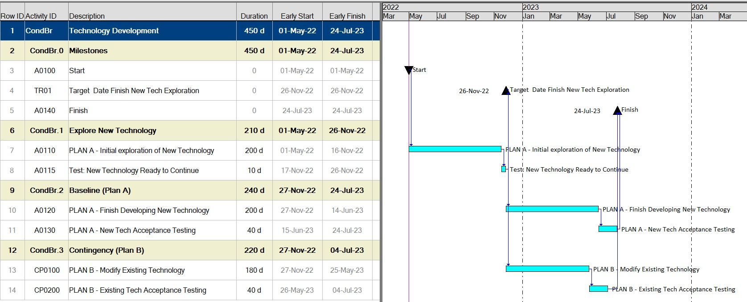
329
330

Figure 6: Baseline and Contingency Plans that Depend on the Duration of the Initial Exploration of New
- Technology
333
334
335 3.2.3. Considerations for a Conditional Branching Model
336
- There are two types of results at play in the conditional branching model. One is related to the timing of the decision and the other one is related to the content or actions after the decision takes place. In our technology selection model, these could be similar to:
- • Time related: When is the facility finished and ready for start-up?
- • Content related: What technology, new or existing, will the plant be using when it starts-up? 340
- Having the project finished on time based on competition to be first-to-market, and the use of Plan B are related. If
- the delay using the preferred technical result of Plan A is too long, Plan B, with the acceptable but less desirable
- technology may be called upon to protect the finish date. 344
- Conditional branching solves for both the finish date and the technology needed to provide a complete
- picture of the resulting scenario for project management to evaluate. The objectives of first product to market and
- type of technology interact in this model. 348
- Leadership needs to evaluate their reaction to the outcomes from the conditional branching model. The model’s
- input assumptions about the uncertainty and risk of developing the new technology on schedule, compared to the
- value of the type of technology embedded in the new facility, depends on the company’s utility for time and
- technology. Conditional branching provides the level of detail to support such decision making. Some assumptions
- of the schedule risk associated with the finish Activity A0110 – “Plan A - Initial Exploration of New Technology” compared
- to the Target Date chosen by management result in switching back to the older technology (Plan B) while other
- assumptions result in executing Plan A, the preferred but novel technology. 356
357 The project team needs to decide if exploring the insertion and testing of a new technology is worthwhile at all if
358 Plan B is a likely outcome as determined by the risks and the target date. Hence, conditional branching offers a
359 richer menu of capabilities than does probabilistic branching. Using conditional branching enables the team to test
360 sensitivity of delays in the project against the use of new technology.

361
362
363 3.2.4. The Conditional Branching Model
364
365 Both Plan A (new technology) and Plan B (existing technology) are included in the schedule, but only one will be
366 chosen for each iteration in the Monte Carlo simulation. A decision event, shown as Activity TR01 “Target Date Finish
367 New Tech Exploration”, is set by the company leadership to be the latest date that they can wait for the testing of the new
368 technology to indicate a successful technology readiness. Factors in this decision might include pressures of market
369 competition, availability of financing, and concerns that the new technology is too immature to be included on this
370 project.
371
372
373 3.2.5. Modelling the Schedule Uncertainty of the Initial Exploration of New Technology
374
375 Assuming that the company leadership were to ask, “How much schedule risk is associated with the initial exploration of
376 new technology?” That question identifies the key “risk driver”. The project champion may respond with
377 an optimistically ranged estimate: a minimum of 100 days (50% of the scheduled 200 days duration), most likely
378 200 days (as scheduled), and a maximum of 400 days (200% of 200 days). The probability distribution shown in
379 Figure 7 applies multipliers as percentages of the planned 200-day task:
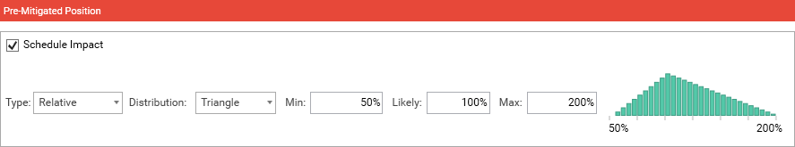
380

381

382 Figure 7: Optimistic Schedule Narrow Ranges Risk Assumption for Initial Exploration
383
384 Another decision maker, perhaps one more experienced at introducing new technology, is pessimistic and might
385 propose a wider distribution. In that estimate, no opportunity exists to do better than the planned 200 days (100%
386 of the scheduled 200 days), most likely is 300 days and the maximum duration is 600 days. That proposed range also
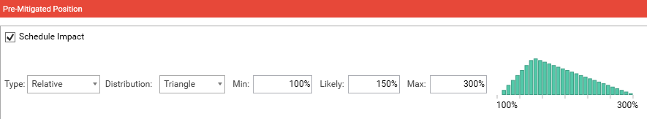
387 applies relative impact ranges as percentages of the estimated duration, Figure 8: 388

389

390 Figure 8: Pessimistic Schedule Wide Ranges Risk Assumption for Initial Exploration
391
392
393 3.2.6. Settling on the Trigger Date
394
- The results exhibit the power of conditional branch modelling. The schedule in this example was subjected to a
- Monte Carlo analysis of 10,000 iterations. In each iteration, the choice of Plan A or Plan B was determined by the
- finish date of “Target Date Finish New Tech Exploration” which in turn resulted from impacts of its risk driver (initial

- exploration of new technology). The team initially agreed that Plan A, new technology, would
- be pursued if the target finish date of March 4, 2023 is not to be exceeded, giving the technology exploration team a
- little more than three months from the scheduled date of November 26, 2022. Or, if the target finish date were
- exceeded, then choose Plan B (Existing Technology). Whether the finish date occurred earlier or later than the trigger
- date in the model depended on the risk associated with the initial exploration activity in each iteration of the simulation.
- The results of holding the trigger date constant at March 4, 2023 while exploring high-risk wide ranges and low-risk
- narrow ranges are seeing in Table 3. 405
Schedule Risk on Initial Exploration of New Technology | Latest Date to use Plan A | Schedule and Technology Choice Results
Activity Risk | Constant Trigger Date | P-80 Date | Plan A New Tech | Plan B Existing Tech
Low Risk: Narrow Ranges | 04-Mar-23 | 02-Nov-23 | 83 % | 17 %
High Risk: Wide Ranges | 04-Mar-23 | 06-Mar-24 | 24 % | 76 %

406 Table 3: Schedule and Technology Outcomes for Narrow and Wide Range Estimates and a Target Date March 4,
407 2023
408
- With low risk represented by narrow ranges on the initial exploration task, the project’s finish date at the P-80 level
- of confidence (2 November 2023) was about 3.5 months later than planned (24 July 2023). That date resulted from
- pursuing the preferred new technology (Plan A) in 83% of the iterations, a positive result from the imposition of
- optimistic risks. The trigger date was exceeded in 17% of the iterations and selected the existing technology (Plan
- B).
414
415 With high risk represented by wide risk ranges on the initial exploration task, different conclusions were found,
416 holding the trigger date at 4 March 2023. With those assumptions, the project’s P-80 finish date (6 March 2024) was
417 4 months later than with the narrower ranges, and Plan B occurred in 76% of the samples (Monte Carlo iterations),
418 and the preferred technology (Plan A) was chosen in only 24% of the iterations. 419
420 Consequently, if senior management was correct in assuming higher risk in the initial exploration of the new technology,
421 the project finish date will be later and existing technology is likely to be implemented (given that choice of trigger
422 date). The debate continued. The team learned from different perspectives and tested different scenarios. 423
424
425 3.2.7. Settling on a Medium Range of Risk for the Initial Exploration of New Technology
426
- The risk model was tested for sensitivities to different risk of completing Activity A0110 “PLAN A – Initial Exploration
- of New Technology”, represented by medium-to-wide risk impact ranges combined with the medium Trigger Date of
- 10 February 2023. Tests of narrower/wider ranges altered the dominance of path Plan A from 75% to 15%. The
- team learned from experimentation how to understand the driving risks and to plan their responses (mitigations).
- Examples are shown in Table 4. 432

Medium Range Schedule Risk for Initial Exploration of New Technology
Combinations of Impact and Trigger Date |  | Paths Likelihoods of Selection
Test Scenario | Trigger Date | P-80 Project Finish Date | Plan A New Tech | Plan B Existing Tech
Medium Range, Medium Date | 10-Feb-23 | 26-Nov-23 | 50 % | 50 %
Narrow Range, Medium Date | 10-Feb-23 | 24-Oct-23 | 75 % | 25 %
Wide Range, Medium Date | 10-Feb-23 | 6-Mar-24 | 15 % | 85 %

433 Table 4: Results by Varying Combinations of Risk with a Medium Trigger date February 20, 2023
434
- Notice that the combination of a medium trigger date and a medium range in this test resulted in a 50% - 50%
- likelihood of each technology path being selected. Varying the degree of risk on the initial exploration task and on
- the choice of a trigger date results in different P-80 finish dates and in the predominant technology outcome. It is
- apparent that management is now wrestling with both risk assessment and the consequences of the trigger date,
- key considerations in making strategic project decisions among alternatives, and learning about risk analysis
- methodologies in the process. 441
442 Management may conclude that only a 25% likelihood of ending up with the desired new technology under a
443 medium range of risk assumptions, given the earlier trigger date, might not justify exploring the new technology it
444 at all.
445
446
447 3.2.8. How the Conditional Branching Model Works
448
449 With both Plan A and Plan B in the risk model’s network logic, the conditional branch chooses one or the other based
450 on predefined conditions. The model instructs one branch to be “hidden” (activities durations take 0 days) and the
451 other branch to be active. If the trigger date is exceeded, then hide Plan A and activate Plan B, as shown in Figure
452 10. Or if the trigger date is not exceeded, then continue with Plan A and hide Plan B, as shown in Figure 11. Figures
453 10 and 11 illustrate snapshots of the model as it made choices between alternate paths. 454

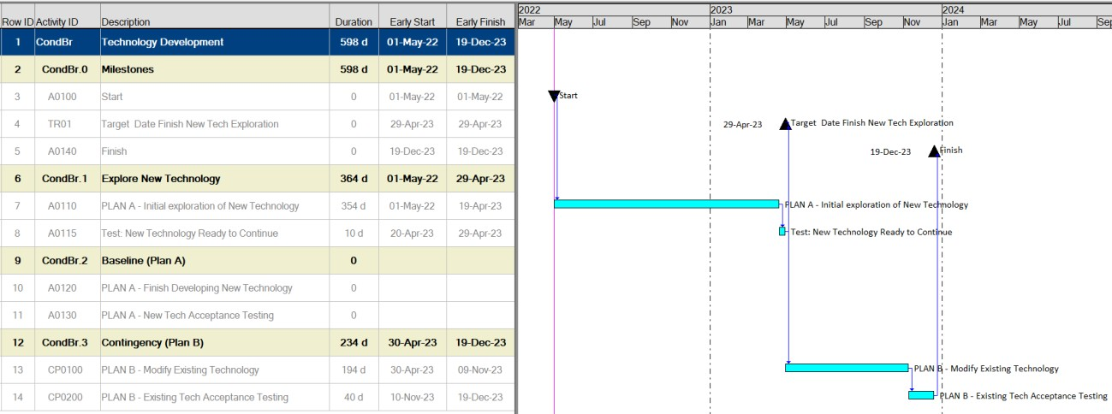
455

456 Figure 10: Plan B is Chosen, Plan A is Hidden
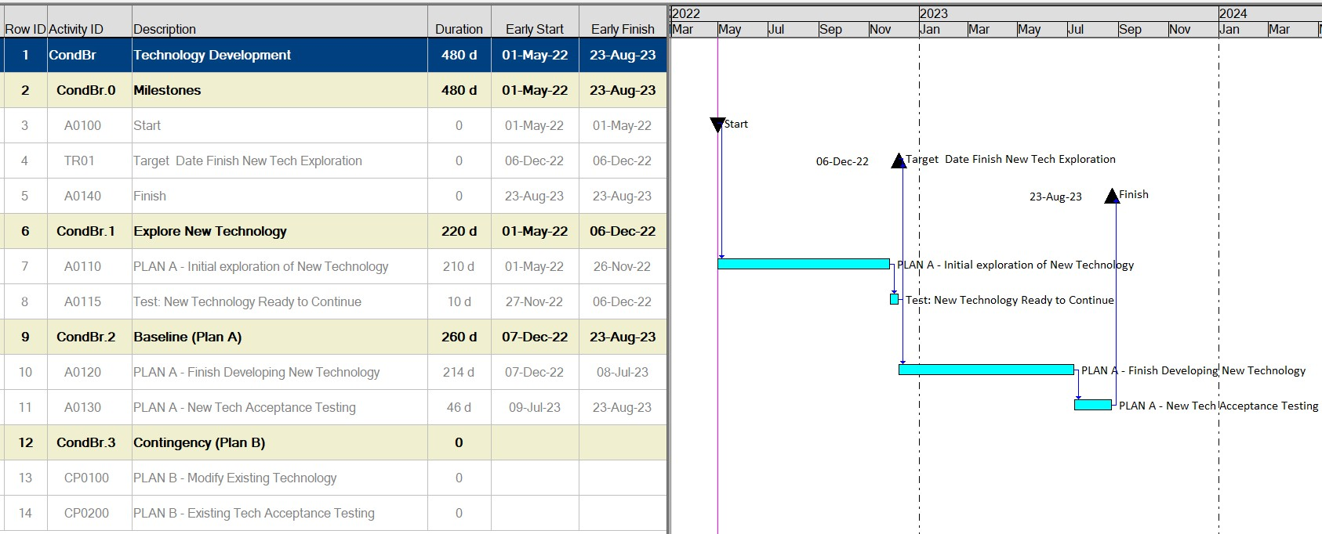
457

458

459 Figure 11: Plan A is Chosen, Plan B is Hidden
460
461
462 4. CONCLUSION
463
- Implementation of these modelling techniques is within a framework of decision analysis⁶. An important benefit of
- modelling decision alternatives focused on the consequences of risks is that management will better understand
- how the project plan is affected by risks. In these cases, it is of whether new technology should be adopted, but it could be the
- risk of locating a plant or entering a new industry. Credibility will increase as teams participate in developing the
- risk structure of the model and the discussions about risk parameters (probability, impact, and mapping of risks to
- activities). Their augmented assortment of policy tools (such as those associated with the probability of a failure or
- deciding the trigger date for conditional branching to a Plan B) enables management to evaluate

⁶ Other familiar figures of merit would typically be considered in conjunction with the practices described here. For example, if each
alternative’s model was cost loaded, then incremental, marginal, additional, and total contributions of each risk to return on investments, impacts of probabilistic cash flows, and schedule performance could be evaluated. (All are beyond the scope of this RP).

- alternatives at a systems level. This experience will encourage ownership of the results, familiarity with the concepts
- of risk analysis and strengthen implementation of the chosen alternatives. 473
- Risk results will be an important element, although not the only element, of this approach to resolving the strategic
- technology decision in a manner that is suitable to the organization. Through quantification and sensitivity testing
- of different views during this decision modelling effort, the organizational executives will discover how projects’
- mutual objectives of using the desired technology and achieving timely completion are related given the risks and
- uncertainty that are deemed to exist⁷. 479
480 Management will be satisfied in the development and implementation of a decision assessment model of
481 strategic policies and an analysis of alternatives in collaboration to reach a joint decision of parameters based
482 on focused discussions. The repeatability and transparency of the methods add to the credibility of the results. This
483 sophisticated modelling is neither difficult nor unknown. It can be applied using commercially available software
484 systems. Once leadership is familiar and confident with this methodology, an independent risk assessment team
485 might be commissioned to make an unbiased estimate of the risk. Then, if the leaders cannot settle on a single
486 assessment of the new technology exploration and results are quite different depending on whom to believe, the
487 organization’s executives will be having deeper discussions about quantified models of uncertainty and risk as important
488 contributors to their decisions. 489
490
491 REFERENCES
492

[1] | H. L. Stephenson, Ed., Total Cost Management Framework: An Integrated Approach to Portfolio, Program and  Project Management, 2nd ed., Morgantown, WV: AACE International, Latest revision.
[2] | AACE International, Recommended Practice No. 40R-08, Contingency Estimating--- General Principles, Morgantown, WV, AACE International, Latest revision.
[3] | AACE International, Recommended Practice No. 57R-09, “Integrated Cost-Schedule Risk Analysis using Risk  Drivers and Monte Carlo Simulation of a CPM Schedule.” Morgantown, WV, AACE International, Latest revision.
493 [4] AACE International Recommended Practice No. 71R-12, "Required Skills and Knowledge of Decision and Risk
494 Management," Morgantown, WV: AACE International, Latest Revision.
495 [5] Tversky, Amos and Kahneman, Daniel, “Judgment under Uncertainty: Heuristics and Biases," Science, New Series,
496 Vol. 185, No. 4157. (Sep. 27, 1974), pp. 1124-1131.
497 [6] Technology Readiness Assessment Guide, Best Practices for Evaluating the Readiness of Technology for Use in
498 Acquisition Programs and Projects, GAO-20-48G, January 2020.
499 [7] Total Cost Management (TCM) Framework, Section 3.3.1.1 Decision Analysis, AACE International second Edition. 500
501
502 CONTRIBUTORS
503
504 Disclaimer: The content provided by the contributors to this recommended practice is their own and does not
505 necessarily reflect that of their employers, unless otherwise stated.
506
- Dr. David T. Hulett, FAACE (Primary Contributor)
- Keith D. Hornbacher (Primary Contributor)
- Francisco Cruz Moreno, PE CCP

⁷ Usually, the decision analysis is conducted on risks that have been subjected to analysis and mitigation. The post-mitigation results indicate residual risk that is impractical to further resolve.

- Dr. Dan Melamed, CCP EVP FAACE
- Abbas Shakourifar, PSP

